CREATION OF AN INTERMEDIATE ENVIRONMENT AND UTILIZING

SWITCHABLE MICROWAVE ABSORBENT MATERIAL TO AID IN

PERFORMING WORK ON MARS

by

S. Andrew Ning

Submitted to the Brigham Young University in partial fulfillment of graduation

requirements for Bachelor of Science degree and University Honors

Department of Physics and Astronomy

April 2006

Advisor: Dr. David D. Allred Thesis Coordinator:

Signature: _________________________ Signature: _________________________

Department Chair:

Signature: _________________________

Acknowledgements

First and foremost I would like to thank my advisor Dr. David D. Allred for countless hours of instruction and guidance. He has given me the freedom and confidence to chase my interests. I will always be grateful for his patience and friendship. I would like to thank Dr. Robert Lawton for helping with the microwave analysis and Dr. Brian Riddle for providing his medical expertise. I would also like to thank other BYU students in the Mars Research Group who have contributed to parts of this project, namely: Niki Farnsworth, Krystle Farnsworth, Rob Gillis, and Donovan Chipman. I would also like to thank my parents and my wife for their support in making this possible. Finally, I would like to thank the Department of Physics and Astronomy, the Office of Research and Creative Activities, and the Rocky Mountain NASA Space Grant Consortium for their generous funding which allowed me the time to work on this exciting project.
Contents

I. Introduction 1
1.1 Manned exploration of Mars 1
1.2 Living on Mars 1
1.2.1 Mars’ atmosphere 1
1.2.2 Space suit design 2
1.3 Full Pressure Suits 4
1.3.1 Problems with full pressure suits. 4
1.3.2 Mars needs new design 4
1.3.3 Simulating Full Pressure Suits 5
1.4 Alternative solution 6

II. Our Solution: Intermediate Environments 7
2.1 Living on Mars 7
2.2 Intermediate Environment 7
2.2.1 Main benefits 7
2.2.2 Additional benefits 8
2.3 Construction 9
2.4 Model 10

III. Heating the Astronauts 12
3.1 Heating with directed microwaves 12
3.2 Electrochromic material 12
3.3 Using microwaves 13
3.3.1 Safety concerns with microwaves 13
3.3.2 Another means of heating 13
3.4 Electrochromic windows 14
3.4.1 Preliminary testing 14
3.4.2 Transparent coatings 16

IV. Designing Heater Substrate 19
4.1 Thermochromic material 19
4.1.1 Vanadium Dioxide 19
4.1.2 Advantages for space suit application 19
4.2 Creating thermochromic materal requires high temperatures 20
4.3 Designing the heater substrate 21
4.3.1 Purchasing a feedthrough 21
4.3.2 Designing the bracket 21
4.3.3 Designing the quartz slide 24

V. Future Work 25
5.1 Follow-up project 25
5.2 Outline of procedure 25

VI. Unmanned Aircraft 27
6.1 Why built aircraft 27
6.2 Designing the aircraft 27
6.3 Future work 28
6.4 New space suit technology 29

VII. Conclusion 30
References 31

Appendixes 33
A. Drawing of bracket design 33
B. Excel calculations for aircraft 34

List of Figures

- Site visit to Sprung Structures
- Model of Intermediate Environment
- Electrochromic mirror
- Schematic of experimental setup
- Conceptual diagram of electrochromic mirror
- Transmission of transparent coating layer in visible region
- Reflectance of transparent coating layer in infrared/microwave region
- RF Magnetron Sputterer
- High current feedthrough
- Bracket modeled in SolidWorks
- Assembly of heater substrate
- Set screw to attach bracket
- Quartz slide modeled in SolidWorks
- Hot wire cutter for airfoils

List of Tables

- Results of reflectance and transmission

Abstract

Building and operating machinery will be essential in Martian exploration. For astronauts to leave the spaceship environment to do work, these three human needs must be met: sufficient counter pressure, oxygen to breathe, and warmth. The use of an intermediate environment can solve the pressure requirement effectively. An intermediate environment pressurized with Martian air would provide sufficient external pressure, allowing the use of a thinner, light-weight suit. The astronauts would need oxygen or mixed gas masks, but would not need their bulky outside suits to provide counter pressure. With external pressure supplied, the bulkiness of the suits can be minimized, thus improving mobility, dexterity, visibility and astronaut energy efficiency. An intermediate environment also has additional benefits in minimizing flammability concerns, minimizing decompression sickness, and saving cost on resources.
To provide warmth to the astronauts we investigate the use of directed microwaves with thermochromic material. This method is desirable for our application because it will allow the suits to be kept thin and will allow control on the amount of heat reaching the astronauts. We chose to make our own thermochromic material by depositing vanadium dioxide on glass substrates. We discuss the construction of a heater substrate to allow high temperatures in our sputtering process. Further research is necessary to determine how well our contemplated thermochromic material demonstrates switchable properties in the microwave region.
I. INTRODUCTION

1.1 Manned exploration of Mars
Landing humans on Mars has become the next step and challenge in space exploration. As President Bush said in relation to human missions to Mars, “Probes, landers and other vehicles of this kind continue to prove their worth, sending spectacular images and vast amounts of data back to Earth. Yet the human thirst for knowledge ultimately cannot be satisfied by even the most vivid pictures, or the most detailed measurements. We need to see and examine and touch for ourselves. And only human beings are capable of adapting to the inevitable uncertainties posed by space travel [1].”
Manned exploration of Mars will not only teach us much about The Red Planet, but it will also foster other scientific advancements and discoveries here on Earth. With a reaffirmed national commitment to manned space exploration, much concentrated research effort and collaboration is needed. One major area that must be addressed for a manned mission to Mars is space suit design.

1.2 Living on Mars
1.2.1 Mars’ atmosphere
One major challenge of supporting a manned mission to Mars is finding a way to live in an environment inhospitable to human life. The Martian atmosphere poses three main threats to human life: the lack of sufficient oxygen, low pressure, and low temperature.
First, Mars’ atmosphere contains little oxygen. The atmosphere of Mars is primarily Carbon Dioxide (95%), with some Nitrogen (2.7%), Argon (1.8%), Oxygen (.13%), and Carbon Monoxide (.07%) [2]. Not only are the oxygen levels too low to support respiration, but also the high levels of carbon dioxide are toxic. Additionally, carbon dioxide in the air may combine with water to form carbonic acid. This can be an irritant to open areas of the body such as eyes, sores, etc.
Second, the pressure level of Mars is too low for human life. Mars has an atmosphere, but its atmospheric pressure is only about 6-7 millibars or about 1/150th that of Earth [2]. This is comparable to Earth at 100,000 feet in altitude. At this pressure not only is the partial pressure of oxygen far too low for the alveoli in our lungs, but also water vapor and blood within the body would boil causing the skin to expand [3].
Third, the temperature on Mars is hostile to human life. Without a thick atmosphere like the earth, little heat is captured from the sun. The average surface temperature on Mars is around -63°C but varies widely from day to night.
These three restraints are major concerns and are the focus of this paper, but they are not the only important considerations for living on Mars. Other challenges include the weaker pull of gravity on Mars (about 1/3 that of the Earth), lack of a magnetic field, high surface winds and associated debris and dust, lack of liquid water, meteorites, and high energy cosmic radiation.

1.2.2 Space suit design
The traditional solution to addressing these problems is what is now commonly referred to as a space suit. In designing a space suit several factors must be considered. First, humans need sufficient partial pressure of oxygen in the lungs to avoid hypoxia [4]. Hypoxia occurs when there is an insufficient level of oxygen in the blood or tissues and can cause symptoms as severe as death. To provide this pressure in a vacuum environment, past NASA explorations have used full pressure suits (FPS) to supply the pressure directly to the body by pressurizing the suit.
The difficulty arises in choosing an appropriate pressure level and gas composition. Ideally, the lowest possible pressure is best, because a pressure differential causes the suit to become stiff like an inflated balloon. This pressure differential restricts the astronaut’s movement and thus low pressure is best [5]. However, if the pressure is too low the astronauts are at risk of hypoxia. NASA has determined a workable pressure and gas composition and has generally run FPS at 296 millibars with 100% oxygen [4]. This mixture provides enough partial pressure of oxygen to the astronaut’s lungs to keep them alive. However, 296 millibar pressure differential is still high, and is the reason why the suits are so stiff and awkward. Additionally 100% oxygen levels cannot be sustained for much longer than 2 week periods [5] as pure oxygen is toxic for humans.
To avoid oxygen toxicity and flammability concerns with pure oxygen, mixed gas suits can be used. This requires a high pressure, however, and has other drawbacks as well. These drawbacks include the added cost of continually monitoring both the partial pressure of oxygen and another inert gas such as nitrogen, the added weight and volume, and an increased risk for decompression sickness [4].

1.3 Full Pressure Suits
1.3.1 Problems with full pressure suits.
Full pressure suits are well designed to provide sufficient partial pressure of oxygen for the astronauts to breathe. This allows the astronauts to survive for limited amounts of time in low pressure, oxygen-poor, cold environments. In effect these suits are miniature self-contained atmospheres. The tradeoff is that the pressure differential created by the suit makes movement awkward and the large helmet makes visibility low. This not only makes movement cumbersome, but dramatically increases the amount of energy the astronaut must expend. In addition, FPS severely limit dexterity, adaptability, and the ability to move rapidly in and out of the living areas.

1.3.2 Mars needs new design
The restrictiveness of FPS was not as critical a factor in past missions to the moon because time on the surface was limited and physical work was minimal. A mission to Mars however, will be much longer. A prolonged mission is necessitated by the respective orbits of Earth and Mars. Robert Zubrin from the Mars Society estimates an 18-month stay on Mars [6]. An astronaut in a FPS can only work for limited amounts of time. Besides the time restriction due to oxygen toxicity, the energy required to move inside the suits is high and cannot be sustained for long periods of time. These restrictions will serious impair the astronaut’s ability to work effectively and efficiently. Work on Mars will be frequent and demanding, as there will be a great need to do servicing, building, and maintenance work on Mars. The nature of the work and the length of the mission magnify the negative aspects of a FPS to an unacceptable level. A new solution is necessary to facilitate astronauts on Mars in performing useful work.

1.3.3 Simulating Full Pressure Suits
To simulate the difficulty of working in a FPS, we contacted the company Sprung Instant Structures. We scheduled a site visit to their facility in West Valley, Utah. Their company builds stress membrane structures which can be set up relatively quickly [7]. We rented three different mock FPS to wear as we performed various tasks in setting up the structure. We hoped to simulate maintenance and assembly work similar to that which astronauts on Mars would have to do. The suits severely impeded our ability to perform even basic functions such as climbing ladders and tightening bolts (Fig.1). The helmets impaired visibility and made ascending and descending a ladder difficult. The gloves impeded dexterity making it extremely difficult to hold and tighten bolts. These difficulties would only be magnified with a pressurized suit.
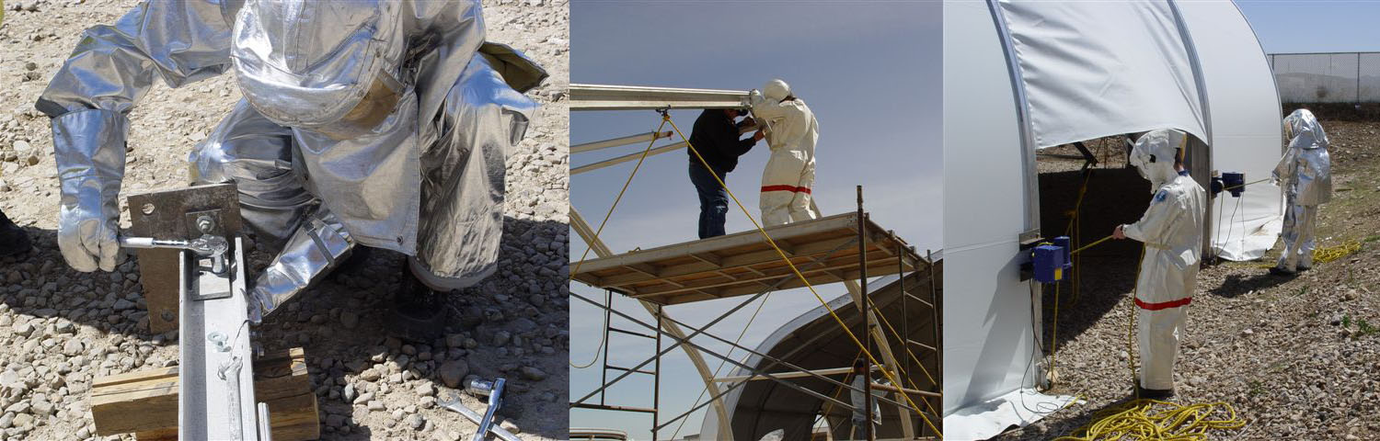
Figure 1: During our site visit we demonstrated the difficulty of performing even simple tasks. Holding bolts, tightening ratchets, and climbing ladders are a few of the challenges we faced.

1.4 Alternative solution
NASA and other research teams are working to optimize new designs in space suit technology. Our objective is unique in that we are not trying to develop a new space suit for Mars; rather, we are working on a supplement to these developments. Any “spacesuit” will have to provide positive pressure to the astronaut in order to support life. Even if that pressure is minimized, movement and dexterity will still be restricted. Instead of creating an optimized space suit, we are looking for an alternative solution to space suits.

II. OUR SOLUTION: INTERMEDIATE ENVIRONMENTS

2.1 Living on Mars
On Mars one of the first major constraints we must address is the low pressure. The pressure level chosen also affects the gas composition that can be used. Unlike a vacuum, Mars has an atmosphere, but the atmospheric pressure isn’t high enough to keep a person alive even while breathing pure oxygen. However, if Mars’s atmosphere were compressed to a pressure greater than 30% of sea level, which is by a factor of 50 or more, it would provide sufficient counter pressure so that an astronaut breathing from a pure oxygen gas mask would not require a pressurized suit.

2.2 Intermediate Environment
2.2.1 Main benefits
Our solution for addressing the astronaut’s need for counter pressure is to construct an intermediate environment on Mars. The contemplated buildings can be pressurized with Martian air thereby providing counter pressure to the astronauts external to any spacesuit. We term the structure an intermediate environment because it has the pressure of the living area of the spaceship, but uses the plentiful Martian air for the ambient. The astronauts would need oxygen or mixed gas masks, but would not need their bulky outside suits to provide counter pressure. Without the need for the suit to provide pressure, a much thinner suit could be designed. It would be similar to a cold environment or high-altitude suit; gloves could even be taken off briefly when needed. A much thinner suit design will allow the astronauts greater mobility, dexterity, visibility and adaptability. Ultimately this will increase their ability to do work on Mars. This will be a tremendous asset in large projects such as building and servicing planes and rovers used for reconnaissance on Mars.

2.2.2 Additional benefits
There are several additional benefits to using a pressurized hangar as an area for astronauts to do work. First, by pressurizing the hangar, movement between the hangar and the living quarters is much easier. A smaller pressure differential will decrease or possibly eliminate the time required for astronauts’ to decompress before moving between pressure differentials. This is a huge advantage especially on a prolonged mission where the risk of decompression sickness is great [4].
Second, the intermediate environment is an inert carbon dioxide environment. This has the advantage of providing a natural and safe place for astronauts to exhaust pure oxygen while pre-breathing in preparation for departure on extra vehicular activity. This is not only beneficial in minimizing flammability safety concerns, but also provides a place for astronauts to do useful work. Current pre-breathe procedures require astronauts to sit idly in an oxygenated room for extended period of times [5; 8].
Third, a thinner suit is more time-efficient in taking on and off. This benefit, along with the lowered risk of decompression sickness, will allow the astronauts to leave the space station more frequently. This will not only allow the astronauts to be more productive, but also has psychological benefits as well. By reducing the restrictiveness of being contained to the living quarters, astronauts would have a greater sense of freedom. The mental health as well as the physical health of the astronauts could further be augmented by use of a greenhouse on Mars. Other BYU Mars researchers have demonstrated the ability to grow and cultivate certain plants in a predominantly CO₂ environment [9]. A greenhouse on Mars could be useful as both a source of food and as a source of aesthetic relief.
Fourth, using Martian air to provide counter pressure will save payload weight by minimizing the amount of air brought to Mars. This is a huge benefit from a cost point of view.
Fifth, this type of structure requires only two major mechanical systems - the pressurizing pumps and possibly an automatic door for moving large objects in and out of the enclosure. This allows the structure to be designed in a modular fashion, permitting easier relocation to different construction sites.
Sixth, this structure could provide a safe haven from cosmic radiation storms, if properly shielded. To shield the structure from cosmic radiation, we propose mounting water barrels to the outside of the enclosure. Water is a good absorber of gamma rays, and thus the enclosure could serve as protective shielding. Further shielding could be provided by using aluminum-lithium sheets [10].

2.3 Construction
Our visit to Sprung Instant Structures (see Section 1.1.2) also served the purpose of evaluating a proposed format for construction of an intermediate environment on Mars. Their ease of setup, size, resistance to high winds, and low-weight to strength ratio make them a good candidate for use on Mars. The design, however, would of course have to be slightly modified for our purpose. Currently the structures are not enclosed at the floor. To contain a pressure differential within the structure, we would need to create a seal around the base of the structure. One possible method would be to dig a trench into the surface of Mars, and anchor our structure by using the weight of the regolith. This should help create a seal allowing positive pressure to exist within the enclosure. Another possible method is to extend the material used for the walls as a floor covering. In any scenario, the enclosure can permit minor leaks as the pressurizing agent (carbon dioxide) is abundantly available.

2.4 Model
Plans are now underway for constructing a table-top version (Fig. 2) of an intermediate environment for modeling purposes [11].
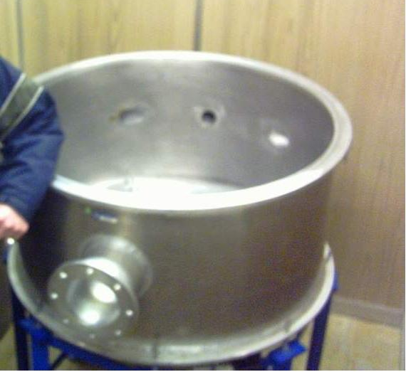
Figure 2: Vacuum chamber that will be used to simulate the intermediate environment (research being conducted by Donovan Chipman from BYU’s Mechanical Engineering Department).
Further testing is needed to determine how much of a pressure differential the membrane structure can withstand. Other questions to consider include: how deep in the regolith would the membrane structure need to be buried, what method would we use to pressurize the structure, where should we land on Mars to set up in a suitable location, what materials will we use, what power sources will we use, how much will the structure weigh, and is the transportation cost justifiable?

III. HEATING THE ASTRONAUTS

3.1 Heating with directed microwaves
With pressure and oxygen requirements met, the remaining task is to find a solution for providing heat to the astronauts in a subzero ambient environment. This problem has the constraint that it is desirable to keep the suits thin in this pressurized environment so that mobility is not restricted. Our solution is to use directed microwaves which could be absorbed by the material of the space suit and then heat the astronauts through conduction. Heating the astronauts directly rather than heating the empty space around them will save on energy [12]. This idea is analogous to warming oneself in front of a fire. The infrared rays warm the individual directly without having to heat the entire surroundings first. We choose to use microwaves rather than infrared because microwaves are easier to direct.

3.2 Electrochromic material
Originally, we proposed to regulate the microwaves by use of electrochromic materials that are switchable in the microwave range. Electrochromic materials are able to reversibly change their optical properties under an applied voltage. This means that the material can switch states between absorbing radiation of certain frequencies to reflecting it. Thus, when the astronauts get too warm a computer that regulates temperature can apply an external voltage to the material and the microwaves will be reflected rather than absorbed by the suit. By supplying heat in this manner, material can be kept thin. This will keep the astronauts warm but will not restrict motion so that useful work can be done.

3.3 Using microwaves
3.3.1 Safety concerns with microwaves
Although the use of microwaves is associated with many negative effects, most of these claims are inconsistent and unfounded [13]. In fact, many recent long-term studies on of the effect of microwaves have failed to show any harmful effects, including cancer [14]. Still the term radiation carries a negative connotation. Most people do not realize, however, that heat coming from fire and radio waves in the air are also types of radiation. Usually when people speak of harmful radiation they are referring to high frequency radiation. The quantum theory of light tells us that higher frequency photons carry higher energy, and thus a higher potential to disrupt normal cell functions. Microwaves are at a lower frequency than infrared light, and so in that respect are even safer.
3.3.2 Another means of heating
There may be potential hazards with using microwaves at high power levels, or possibly in connection with very thin or pointed metal which could cause an arc of electricity. These concerns, however, are easily avoidable through proper design. The only real concern when dealing with microwaves is the same concern with any heating application: overheating, burning, etc. Tissue heating is, of course, an effect demonstrated by microwaves. It is not a danger, but of course something that needs to be regulated. Electrochromic material provides an excellent means for controlling the amount of microwaves absorbed. In this manner, low power microwaves are a great potential source of heating energy. As Adair has said, “… heating of human beings with electromagnetic energy has yet to be brought to fruition, principally because of the persistence of electrophobia in the general population . . . those of us who measure human responses to diverse RF/MW fields are confident that this electromagnetic energy will play a large role in the thermal control of personal environments in the future, whether in the home or in a space capsule [14].” We also hope to see the use of microwaves in future heating applications on Mars.

3.4 Electrochromic windows
3.4.1 Preliminary testing
To determine the feasibility of using electrochromic material we performed some preliminary tests using a “smart window” we received on loan from SAGE Electrochromics (Fig 3).
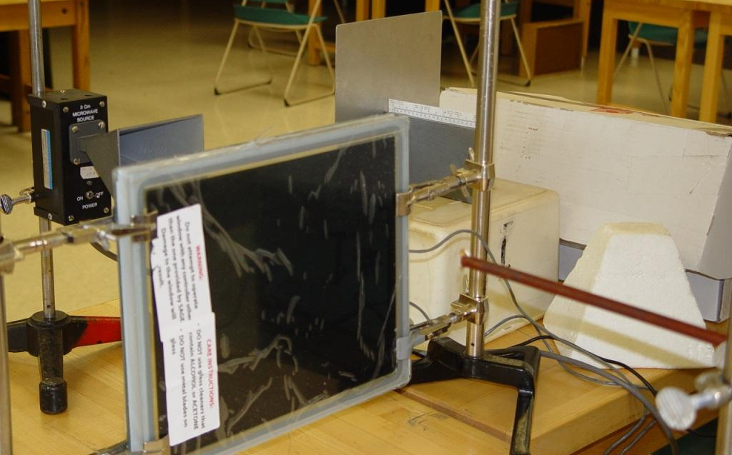
Figure 3: Electrochromic mirror with a microwave source in the background and detector in foreground. We found the mirror to be ineffective in demonstrating electrochromic properties in the microwave frequencies we tested.
We performed tests to see if the window would demonstrate switchable properties in the microwave region. We used a 3cm wavelength microwave source and a diode microwave detector to measure the intensity of the microwaves (Fig. 4).
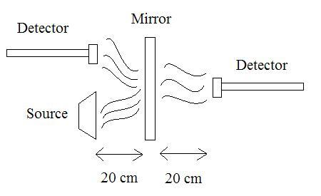
Figure 4: Schematic of our experimental setup
We measured the intensity of microwave reflection and transmission through the electrochromic material. This was done in both the “clear” and “tint” settings, taking care to not change orientation of the window or the detector. Our tests showed no significant difference between the “clear” and “tint” settings for our wavelength of microwave. Further, our tests showed that the mirror behaved like a metal in the microwave region and attenuated the signal. We compared our intensity results with aluminum, and found that the microwave signal was attenuated in a similar manner (Table 1). In effect, the “smart window” did not demonstrate any switchable properties in the microwave region.

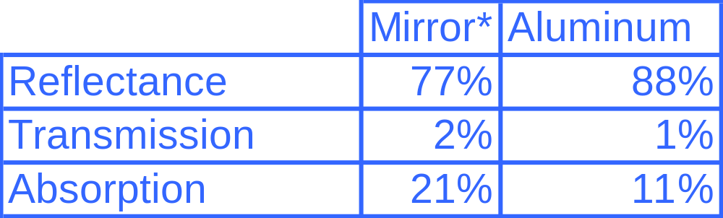
Table 1: Results of reflection and transmission

3.4.2 Transparent coatings
Further study revealed that the window’s “failure” to switch in the microwave region was due to the electrically conductive transparent coatings that are necessary in these types of smart windows (Fig. 5).
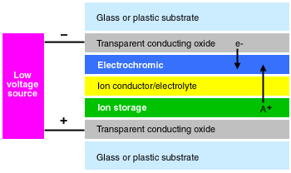
Figure 5: Conceptual diagram of an electrochromic mirror. To facilitate electron flow, the electrochromic layer must be sandwiched between two conducting layers. These layers reflect microwaves and thus do not allow us to test the microwave properties of the electrochromic material.
In order to facilitate electron flow, the electrochromic layer must be sandwiched between two conducting layers. This material of the conducting layers allows high transmission in the visible region of light (Fig. 6) but demonstrates high reflectivity in the far infrared region and beyond (Fig. 7).
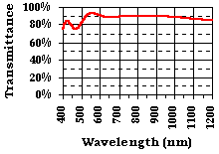
Figure 6: Graph of the transmittance vs. wavelength of the transparent conducting oxide layer. Here we see that the coatings allow high transmittance in the visible region.
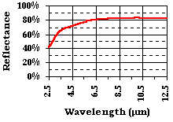
Figure 7: Graph of the reflectance vs. wavelength of the transparent conducting oxide layer. Here we see that the coatings reflect most light in the far infrared region and into the microwave region.

Thus, the coatings on the window reflect the microwaves before they can even reach the electrochromic material. At this point, we concluded that either we would need to look into another method such as polarized microwaves, or we would have to make our own electrochromic material.
IV. DESIGNING HEATER SUBSTRATE

4.1 Thermochromic material
4.1.1 Vanadium Dioxide
As the technology was readily available here at BYU, we decided to make our own electrochromic material to meet our specifications. After a literature review we found a study done by Wang et al. [15] which suggests a preparation method using a thin film of vanadium dioxide to coat glass. Vanadium dioxide is a fascinating material for its property of undergoing a phase transition from a semiconductor to a metal at a temperature of around 68°C [16]. This change in state is accompanied with a change in its optical properties. It can reversibly change from a state of reflectance to a state of transmittance. For this material, the change of state is controlled by temperature (thermochromic) rather than by voltage (electrochromic).

4.1.2 Advantages for space suit application
This ability to undergo a phase transition according to temperature is advantageous for our space suit material application. This allows our material to act as a self-regulating thermostat. Our objective in making thermochromic material is to prepare it so that it demonstrates switchable properties in the microwave region. Secondly, we would like to prepare our material so that its critical temperature is at an appropriate level for heating astronauts by conduction. To achieve these objectives requires careful setup of the preparation conditions.

4.2. Creating thermochromic materal requires high temperatures
We planned to deposit our glass samples with vanadium dioxide using a RF magnetron sputterer located in U234 of the Eyring Science Center (Fig. 8). To product a single phase of vanadium dioxide, Wang suggests the need to reach temperatures greater than 600° C [15]. Higher temperature will not only allow us to access different structures, but will also increase atom mobility allowing the atoms to diffuse. This will allow us to create bigger crystals with fewer defects. The challenge was that our RF magnetron sputterer did not have the capability to heat our samples to the desired temperature.
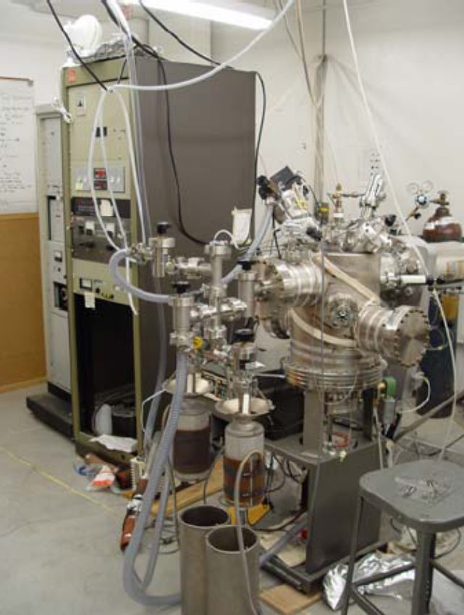
Figure 8: RF Magnetron Sputterer commonly referred to as “Joey”

4.3 Designing the heater substrate
4.3.1 Purchasing a feedthrough
In order to achieve temperatures greater than 600° C we decided to design a substrate heater. To connect a substrate heater to our RF magnetron sputterer required that we purchase a feedthrough to act as a connector. It was necessary that this feedthrough be made of conductive material so that it could carry high currents. It is important to drop as much of the power as possible into our heater substrate not only to improve efficiency but also to prevent damage of other parts. Copper was chosen as a suitable material to meet these needs. Copper has a high conductivity that should allow us to reach temperatures well over 600° C. We found a suitable copper feedthrough made by CeramTec capable of conducting 185 Amps of electricity. The part we purchased was a ¼ inch high current feedthrough for a 2 ¾ inch ConFlat flange (Fig. 9).
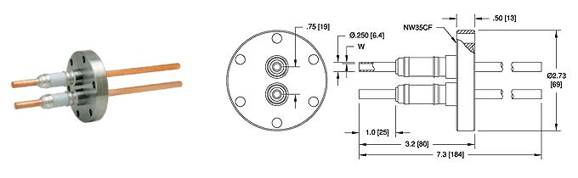
Figure 9: A ¼ inch high current feedthrough for a 2 ¾ inch ConFlat flange from CeramTec (Part# 16705-01-CF).

4.3.2 Designing the bracket
After the feedthrough was purchased we began the design of a bracket. To ensure a proper fit we measured the dimensions of our feedthrough cross section, our quartz substrate area, and the diameter of our RF Magnetron Sputter opening. These dimensions served as the constraints to create a first draft on paper. This design was further modified and later modeled on the computer using SolidWorks (Fig. 10).
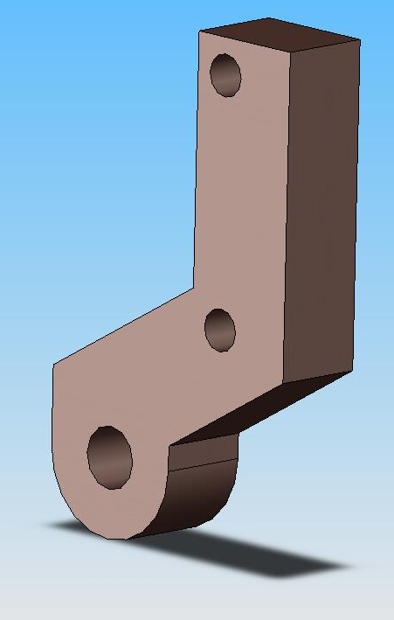
Figure 10: Bracket modeled in SolidWorks

This bracket was designed be assembled with the feedthrough and the quartz slide as seen in Figure 11. To cut the copper we decided to use a water jet which is available in the Precision Maching Laboratory in the basement of the Crabtree Building. We created a drawing based on out computer model (Appendix A) and then used its dimensions to program the water jet. The water jet was chosen over a saw because of the small size of the piece and the curved surface on the bottom of the piece. Water jet cutting is not as precise as other methods such as the Wire EDM, but tight tolerances were not necessary for this design. After the part was cut out the holes were drilled by use of an end mill. Finally, to attach this bracket to the feedthroughs we tapped a hold on the sides for a set screw which could be tightened by use of an Allen wrench (Fig 12).

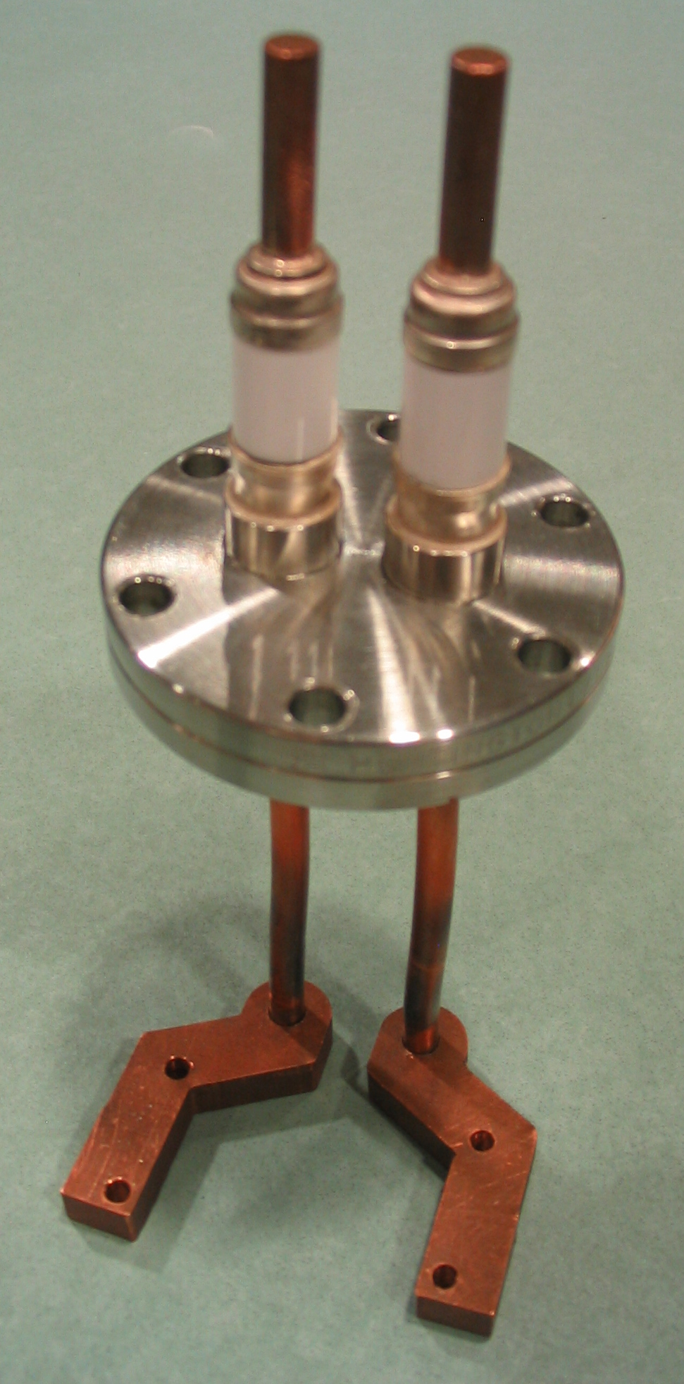
Figure 11: Assembly of bracket mounted to feedthroughs

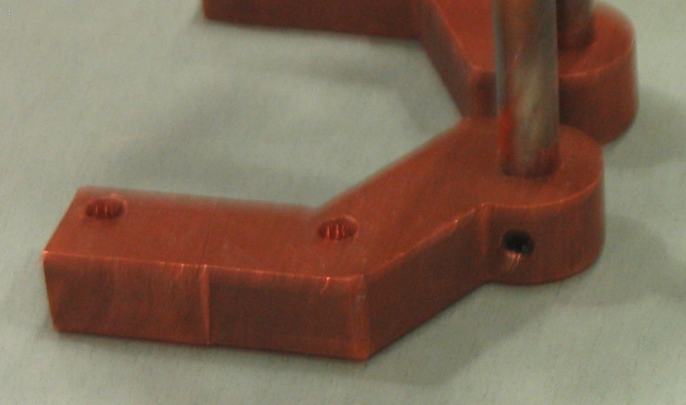
Set screw
Figure 12: Set screw used to attach bracket

4.3.3 Designing the quartz slide
Now that the bracket was designed and attached to the feedthrough, we needed to modify our quartz slide to clamp it to the brackets. The clamps were designed to hold down the quartz slide, but the slide needed to be modified to fit between the clamps. This requires the slide to be machined as seen in Figure 13.
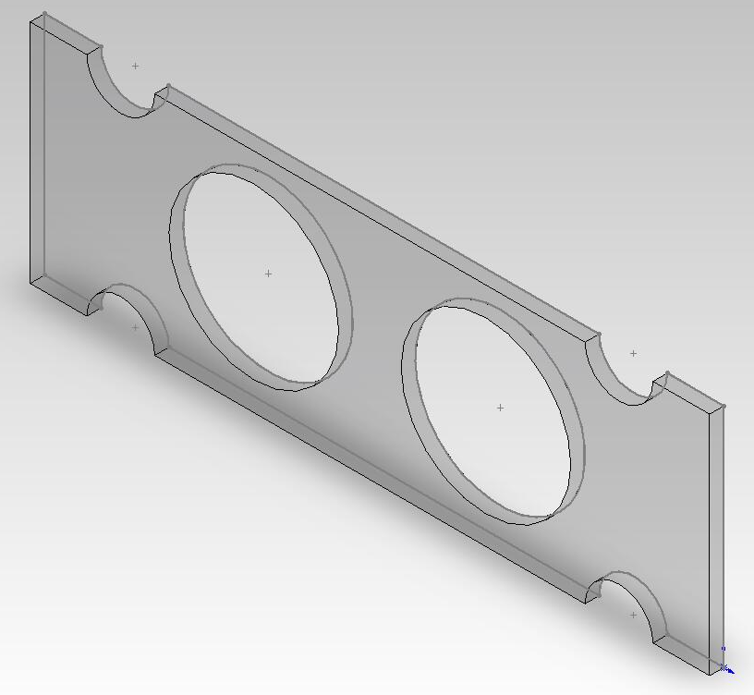
Figure 13: Model of quartz slide designed in SolidWorks
Cutting quartz however, was a much greater challenge than cutting copper. Our quartz substrates our highly cross-linked to allow them to heat up to high temperatures. Though this is good for our heating application, this cross linking makes the quarts break in unpredictable ways. Because the quartz is brittle rather than ductile, and its size is small, cutting our substrate was a challenge. In 1995 Dr. Allred and Dr. Todd published a paper on techniques for cutting glass using a water jet [17]. This paper suggests that by using Styrofoam for support and weights to hold down the material, glass can be cut by use of the waterjet. This method is currently being pursued in the machining lab.
V. FUTURE WORK

5.1 Follow-up project
This section presents work that has not yet been done, but will be in the upcoming months either by myself or another student. This part of the project was not in the original scope of our study, but is a logical follow-up to our work. An outline of the procedure is described below. Though the outline is simple, the work is not trivial and constitutes an entire summer project alone.

5.2 Outline of procedure
First, we will deposit the glass with vanadium dioxide using a RF magnetron sputterer located in U234 of the Eyring Science Center (ESC). The newly built heater substrate will allow us to achieve the higher temperatures necessary for our thermochromic material. To produce a single phase of vanadium dioxide we will experiment with different oxygen-argon ratios (controlled by use of a mass spectrometer), temperatures, and bias. This process will be iterated until we find optimal depositing conditions.
After we have sputtered the films we will use the ellipsometer in C376 of the Benson building to analyze our sample. This will allow us to determine the optical constants of our sample, the thickness, and the deposition rate.
Next we will put our sample on a hot plate heated to approximately 375 K. Because vanadium dioxide is thermochromic, we hope to observe a color change indicating a metal to semiconductor switch as it heats past the critical temperature and another switch as it cools back down.
When we are satisfied with the composition of our sample we will make a thicker one, about a micron in thickness. We will also use X-ray diffraction techniques using the SCINTAG XRD in S318 of the ESC. This will allow us to determine the phase of our material. Again we will run it through the ellipsometer to determine the optical constants and other properties of our material.
Lastly, we will use a microwave source to test our material to determine if in fact it does demonstrate switchable properties. This will be followed up with testing to determine how temperature varies with microwave intensity, frequency and distance as microwaves pass through our material in both the reflectance and transmittance state.

VI. UNMANNED AIRCRAFT

6.1 Why built aircraft
As a project of secondary importance we designed and built an unmanned aircraft. This project was meant to serve as a motivation for one of the possible applications that requires the design of mobile space suits as outlined previously in Section 1.3.2. The work done here is by no means comprehensive as it relates to unmanned aircraft, but is to serve as a starting point for future researchers who will continue this work. The use of unmanned aircraft technology will be an invaluable aid in reconnaissance on Mars, and is an active area of research [18]. With unmanned aircraft astronauts can collect more data, conduct search and rescue missions, map out hazardous terrain, and minimize the effect of introducing alien species to Mars.

6.2 Designing the aircraft
Our aircraft was designed using the model outlined by Dr. Bowman and Dr. Snyder of the Mechanical Engineering Department [19]. To allow us to change the parameters of our aircraft easily, the formulas were entered into a spreadsheet (Appendix B). This allowed us to easily change parameters such as the aspect ratio, taper ratio, and range to see their effects on other parameters such as span and drag coefficient. After we were satisfied with our design we entered our values into a computer program that controlled a hot wire cutter. This wire cutter was used to cut the foam for our airfoil (Fig 14). After the airfoil was cut it was reinforced with electrical tape and fiberglass rebar. Next, we needed to cut locations for our components. We wanted to add a battery, propeller, elevons, and two servo motors. To put the components in appropriate locations, we did some stability calculations of our center of mass and center of gravity. Finally, we tested to make sure all of our electrical components functioned properly.
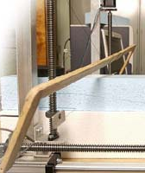
Figure 14: Hot wire cutter used to cut foam for airfoil
6.3 Future work
Our spreadsheet allows quick modifications for a user who wishes to make an aircraft appropriate for a Mars environment. On Mars the air density is much lower and gravity is lower. These adjustments can easily be made in the spreadsheet. Testing of a Martian aircraft, however, would be difficult in our facilities. Future researchers may chose to use the technique of similarity modeling, as often used in experimental fluid mechanics, to create a model of a Martian plane designed for Earth parameters.

6.4 New space suit technology
In designing, constructing, and flying the aircraft it is quickly apparent that such work would be extremely difficult, if not impossible, in current space suits. Thus, there is a great need for a space suit design that accommodates high mobility and dexterity. Unmanned aircraft technology would be invaluable on Mars, and therefore space suit technology must step forward.

VII. CONCLUSION

Building and operating machinery such as unmanned aircraft will be essential in Martian exploration. To facilitate this need, we propose the use and design of intermediate environments on Mars. By designing an enclosure pressurized with Martian atmosphere, astronauts will be allowed to wear a thin, flexible light weight suit while still having sufficient counter pressure on the body. This will improve astronaut mobility, dexterity, visibility. Ultimately this will allow more useful work to be done. Additionally this intermediate environment will save money on resources, provide an inert safe working environment, and reduce the risk of decompression sickness.
Heating concerns could be addressed by using directed microwaves absorbed by thermochromic material. Vanadium Dioxide is a good candidate for this material as its properties suggest that it will optically switch from a state of reflectance to a state of transmittance in the microwave region. The design of a heater substrate allows a user to construct single phase vanadium dioxide using a regular RF magnetron sputter system. This material could be used in space suit applications, keeping the astronaut warm with thin material that is not restrictive. This is a huge advantage in an energy-poor environment where work will be frequent and demanding.

REFERENCES

[1] G. W. Bush, “President Bush Announces New Vision for Space Exploration Program,” speech given at NASA Headquarters, (Office of the Press Secretary, Washington D.C. 2004).

[2] D. R. Williams, Mars Fact Sheet, 2004, Online posting, http://nssdc.gsfc.nasa.gov/planetary/factsheet/marsfact.html, 06 May 2005.

[3] M. Curry, A Brief History of the Pressure Suit, 2004, Online posting, http://www.nasa.gov/centers/dryden/research/AirSci/ER-2/pshis.html#Why, 06 April 2006.

[4] J. Conkin, The Mars Project: Avoiding Decompression Sickness on a Distant Planet, Houston, TX, National Space Biomedical Research Institute, 2000.

[5] P. D. Campbell, Internal Atmospheric Pressure and Composition for Planet Surface Habitats and Extravehicular Mobility Units, Houston, TX, Man-Systems Division NASA, 1991.

[6] R. Zubrin, The Case for Mars. (Touchstone, New York, 1996), p. 80.

[7] Sprung Instant Structures, 2006, Online Posting, http://www.sprung.com/, 07 April 2006.

[8] R. K. Fullerton, Options for Extravehicular Activity (EVA): Now and Future, Houston, TX, NASA Johnson Space Center, EVA Project Office.

[9] J. Jackson, N. Farnsworth, and D. Allred, “Green Thumbs for the Red Planet,” presented at College of Physical and Mathematical Sciences: Spring Research Conference, (Provo, UT, March 2005).

[10] Martian Habitat Design, Mars or Bust Inc. (University of Colorado, Boulder, CO 2003).

[11] D. Chipman, A. Ning, and D. Allred, “Intermediate Martian Atmospheric Demonstration and Study,” (to be published).

[12] R. V. Pound, “Radiant Heat for Energy Conservation,” Science, 208, (1980).

[13] J. C. Lin, “Scientific Literature on Biological Effects of Radio Frequency Radiation: Criteria for Evaluation,” IEEE Antenna’s and Propagation Magazine, 44, 2 (2002).

[14] E. R. Adair, and R. C. Petersen, “Biological Effects of Radio-Frequency/Microwave Radiation,” IEEE Trans. Microwave Theory Tech., 50, 3 (2002).

[15] X. Wang, et al., “Preparation of Thermochromic VO₂ Thin Films on Fused Silica and Soda-lime Glass by RF Magnetron Sputtering,” Jpn. J. Appl. Phys., 41, 2002, pp. 312-313

[16] H. T. Yuan, et al., “Research on Optical Property of Phase Transition PcNi/VO₂ Films,” Applied Surface Science, 243, 2005, pp. 36-39.

[17] F. Yuan, J. A. Johnson, D. D. Allred, R. H. Todd, “Waterjet cutting of cross-linked glass,” J. Vac. Sci. Technol., A 13(1), 1995, pp. 136-139.

[18] G. Pisanich, Initial Efforts towards Mission-Representative Imaging Surveys from Aerial Explorers, Moffett Field, CA, NASA Ames Research Center, 2004.

[19] W. J. Bowman and D. O. Snyder, “A Minimalist Approach to Teaching Aircraft Design,” 43rd AIAA Aerospace Sciences Meeting and Exhibit, 2005, pp. 1-10.

Appendix A: Drawing of bracket
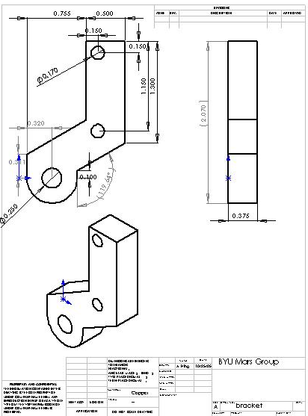

All dimensions are in inches, the material is specified as copper, and no tolerances are specified as it was not necessary in our design.
Appendix B: Excel calculations for aircraft

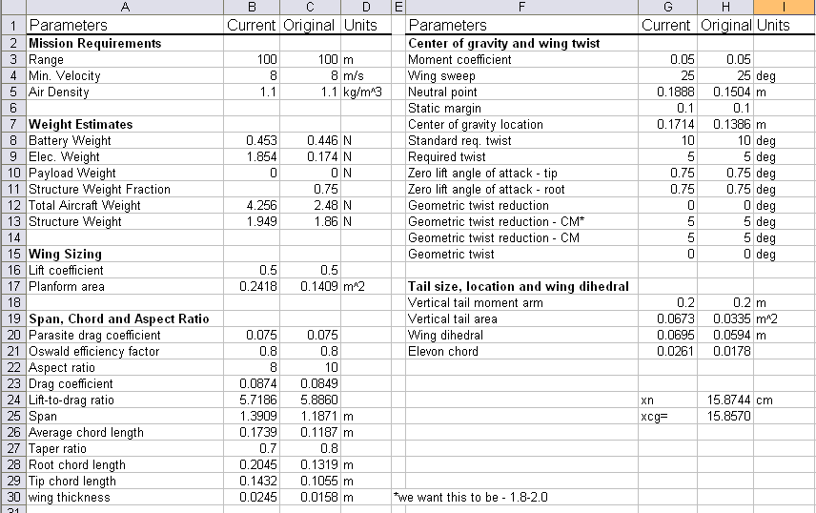

This Excel spreadsheet follows the formulas and guidelines outlined in [19]. Formulas are entered into the cells to allow quick modification of parameters. Two columns are used so the resulting modification from different design decisions can be compared easily.

